Force: An action upon an object (such as push, pull, attraction, repulsion) that causes an object to accelerate. (Recall Newton’s Second Law of Motion) $\vec{F}=m\vec{a}$


Applied Force: The simplest of forces, when an object makes contact and pushes or pulls on a second object. Frequently represented as $\vec{F}$ or $\vec{F_{a}}$. (foot applies force to ball)
Force of Gravity $\vec{F_{g}}$: The attractive force between all objects with mass. The greater the mass of an object, the greater attractive force that object applies to other objects. However, the gravitational attraction between objects decreases with their distance.
Acceleration Due to Gravity (g): The acceleration on an object due to the force of gravity acting on the object. This can be treated as a constant near the surface of a large mass (such as the Earth or Moon). WARNING: g=9.81m/s² is not a constant, that is acceleration due to gravity on the surface of Earth. g can be different at other planets, moons, locations, etc.
Gravity Equations
Force of Gravity near the surface of massive body Force of gravity between two masses acceleration due to gravity on a body mass M
$\vec{F_{g}}=m\vec{g}$ $F_{g}=\frac{G*m_{1}*m_{2}}{r^{2}}$ $g=\frac{G*M}{r^{2}}$
Normal Force $\vec{F_{n}}$: A reaction force from a surface that is perpendicular to the surface. If a force is applied onto a surface (the force of gravity acting on a book on a table, your bottom on your chair, a car on a ramp), to prevent the body from breaking through the surface, the surface applies a perpendicular (normal) force from the surface to the body. If the surface is horizontal, the normal force is equal and opposite to the force of gravity. WARNING: Normal forces are not always vertical; they are perpendicular to a surface and can be at any angle.
Tension Force$\vec{F_{t}}$: The internal force from an object that is being stretched, such as a bungy, on the object attached to either end of the rope to pull the rope back together to its original length.
Friction: A surface’s resistance to having an object or different surface move along it.
Static Friction $\vec{F_{s}}$: The frictional force between a surface and a stationary object or surface. Example: The friction between a table and the floor. When one tries to push a table, it doesn’t initially move (might seem to stick to the floor) due to the static friction between the table and the floor.)
Kinetic Friction $\vec{F_{k}}$: The frictional force between a surface on an object or different surface moving along the surface. Friction Equations
Static Friction Kinetic Friction
$\vec{F_{s}}=μ_{s}\vec{F_{n}}$ $\vec{F_{k}}=μ_{k}\vec{F_{n}}$ $μ_{s} \& μ_{k}$: coefficients of static and kinetic friction, different for each surface.


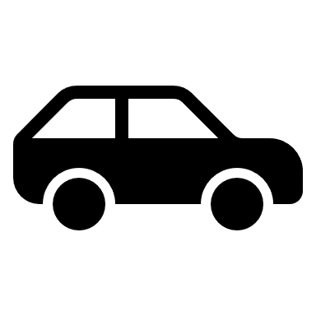
Common Misconception: Cars use kinetic friction when driving. This is False, cars use static friction. When a car is driving, it is moving, however, the wheels are turning, not sliding along the road, relative to the road, the tire is not moving, only pushing down on the road, using static friction to propel car forward.


Spinning wheel applies force to the road, pushing back. The road pushes back on wheel in the opposite directing with static friction, this propels the car forward, the wheel rolls, but does not slip, no rubbing, no kinetic friction.

$$\vec{F_{a}}$$
$$\vec{F_{s}}$$

